Safety Monitor Requirements 2024/25

October 2024

# Safety Monitor Requirements

Introduction

This document sets out ‘Safety Monitor’ for the 2024/25 Winter, pursuant to the obligations of National Gas Transmission under the Uniform Network Code (UNC), Section Q.

The Safety Monitor requirements this year for Space and Deliverability are 0GWh and 0GWh/d respectively. This is equal to the requirements calculated in September 2023 for Winter 2023/24 which were 0GWh for Space and 0GWh/d for Deliverability. It is acknowledged that should the Non-Storage Supplies (NSS) figure change through the winter period, National Gas Transmission reserves the right to review the monitor to reflect such changes and ensure a reasonable degree of accuracy.

Safety Monitor defines levels of storage that must be maintained through the winter period. The focus of the Safety Monitor is public safety rather than security of supply. It provides a trigger mechanism for taking direct action to avoid a potential gas supply emergency (as defined in the Gas Safety (Management) Regulations).

Safety Monitor Methodology

It is our responsibility to keep the Safety Monitor under review (both ahead of and throughout the winter) and to adjust if it is appropriate to do so based on the information available to us. In doing so, we must recognise that the purpose of the Safety Monitor is to ensure an adequate pressure can always be maintained in the network and thereby protect public safety. It is therefore appropriate that we adopt a prudent approach to setting the Safety Monitor levels.

The concept behind the Safety Monitor is to provide sufficient gas in storage to support those gas consumers whose premises cannot be physically and verifiably isolated from the gas network within a reasonable time. To achieve this, all gas consumers are categorised into one of two groups:

* Protected by Monitor - Gas is held in storage to facilitate continuity of supply to these consumers even in a 1 in 50 winter
* Protected by Isolation – Network safety would be maintained, if necessary, by physically isolating these customers from the network

The Safety Monitor has two components. These are the storage deliverability and storage space Safety Monitors. The storage deliverability Safety Monitor indicates the minimum level of deliverability required to both safely isolate loads that are “Protected by Isolation” and support loads that are “Protected by Monitor”. The deliverability Safety Monitor is therefore providing operational cover should an emergency be called on any day, whilst the space Safety Monitor provides sufficient gas in store to support “Protected by Monitor” loads for the remainder of the winter.

The level of the Safety Monitor is dependent on the level of non-storage supply (NSS) available and therefore if the level of NSS reduces, the Safety Monitor will increase. This assessment is undertaken on a regular basis by National Gas Transmission throughout the winter period.

Operation of Safety Monitor

It is a requirement of National Gas Transmission’s Safety Case that we operate this monitor system and that we take action to ensure that storage stocks (space) do not fall below the defined level. The level of storage established by the Safety Monitor is that required to underpin the safe operation of the gas transportation system. Its aim is to ensure the preservation of supplies to domestic customers, other non-daily metered (NDM) customers and certain other customers who could not safely be isolated from the gas system, if necessary, to achieve a supply-demand balance and thereby maintain sufficient pressures in the network.

The space Safety Monitor defines the minimum level of stored gas required in aggregate in all UK storage, on each day of the winter. We monitor the level of gas in all storage facility types throughout the winter to ensure that the actual aggregate stock level does not fall below the space Safety Monitor level. If this were to occur, there would be insufficient gas left in storage to underpin the safe operation of the system in a 1 in 50 cold winter. Under these conditions, we would therefore be obliged by our Safety Case to take action to remedy this situation. In the lead-up to such a situation, we would advise the market with the objective of encouraging mitigating action. If necessary, however, the Network Emergency Co-ordinator (NEC) may require the relevant storage operators to reduce or curtail flows of gas out of storage. In this situation, we would expect the market to rebalance to achieve a match between supply and demand.

The combination of relevant information and clarity of the remaining storage position should assist market participants in ensuring security of supply. While National Gas Transmission would seek to minimise the extent of any intervention in the market, the balance between allowing the market to resolve the situation and acting via the NEC will clearly depend on the severity of the situation and the associated timescales.

Approach to the Safety Monitor levels

This note is published in conjunction with the 2024/25 Winter Outlook Report, which contains more detailed coverage of our preliminary view of supplies for the coming winter. As with previous years we will continue to review the Safety Monitor levels throughout the winter and, if necessary, we will revise them to reflect material changes to the supply-demand balance. National Gas Transmission will continue to provide winter feedback to industry regarding supply assumptions and resulting changes to Safety Monitor by means of monthly updates via Operational forums and our reporting on our website.

Supply Assumptions

The process used to determine our supply assumptions is driven by changing supply patterns resulting from falling gas demand. This section summarises the process. Further detail is provided in the Winter Outlook Report.

Figure 1 shows the NSS versus demand relationship for this year’s Safety Monitor. The data set to create this chart is from the past 5 Winters with a weighting towards the most recent Winters.

**Figure 1 – Non storage supply (NSS) versus demand for the winters of 2019/20 to 20232/24.**

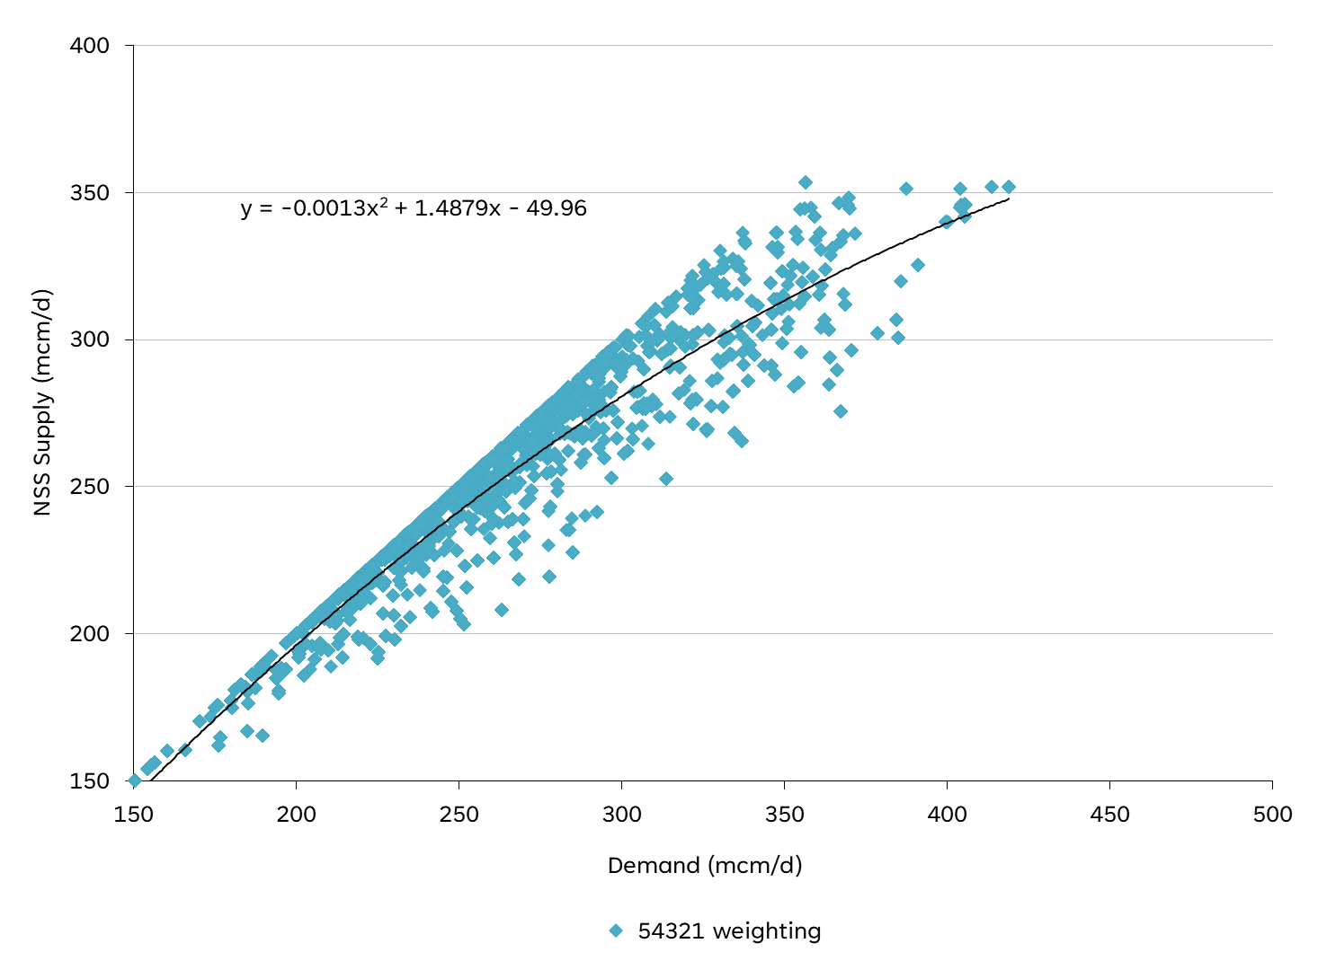

Figure 1 shows the NSS versus demand assumption for Winter 2024/25, based on an analysis of the last five winters. This is used to establish a curve of how NSS is expected to change with demand. This continues the approach of using a variable NSS assumption which is demand dependent. The curve is then adjusted to meet our assumed NSS at a severe demand level, which is established for the upcoming winter. For winter 2024/25 we assume 415 mcm/d of NSS would be available at a demand of 419 mcm/d. It is important that the assumed level of NSS used for calculating the Safety Monitor is available throughout the winter, notably at times of high demand. Hence in calculating the Safety Monitor, NSS at lower levels (98%) are used. There is also the further option to adjust the NSS assumption by a Winter Risk Factor – for any specific supply issues we feel may arise during the winter. This winter this factor is zero.

Within winter, monitoring of actual NSS levels will enable us to determine whether the NSS versus demand relationship used within the Safety Monitor calculation methodology is fit for purpose: if it is found not to be, it can be revised based on the latest information.

Table 1 shows the anticipated availability of storage in winter 2024/25.

**Table 1 – Storage Space and Deliverability Assumptions**

|  |  |  |
| --- | --- | --- |
| Storage Type | Space (GWh) | Deliverability (GWh/d) |
| Medium (MRS) | 18,887 | 1,205 |
| Long (Rough) | 16,554 | 125 |
| Total | 35,441 | 1,330 |

Demand Assumptions

The basis for the calculation of the Safety Monitor levels is our 2024 demand forecasts for 2024/25, using a severe (1 in 50 cold) load duration curve.

Safety Monitor Levels

Table 2 shows the initial Safety Monitor requirements for Space and Deliverability.

**Table 2 – Stored Safety Gas and Storage Deliverability Requirement**

|  |  |  |  |  |  |
| --- | --- | --- | --- | --- | --- |
| Assumed total storage space (GWh) | Space (GWh) Safety Monitor (GWh) | Space requirement (%) | Assumed total storage deliverability (GWh) | Deliverability Safety Monitor (GWh/d) | Deliverability requirement (%) |
| 35,441 | 0 | 0% | 1,330 | 0 | 0% |

The Safety Monitor space and deliverability requirements for Winter 2024/25 are in line with last year’s requirements.

Monitor Profiles

Figure 2 shows the space profile and deliverability profile for the Safety Monitor. The objective of the Safety Monitor profile is to identify at any point in time the requirement for gas in store to underpin the safe operation of the gas transportation system for what remains of the winter period. The Safety Monitor allows for the possibility of late winter cold weather patterns based on analysis of historical temperatures. However, in the event of cold weather earlier in the winter, the profiles may be reduced to reflect the occurrence of cold weather.

**Figure 2: Safety Monitor Profile**

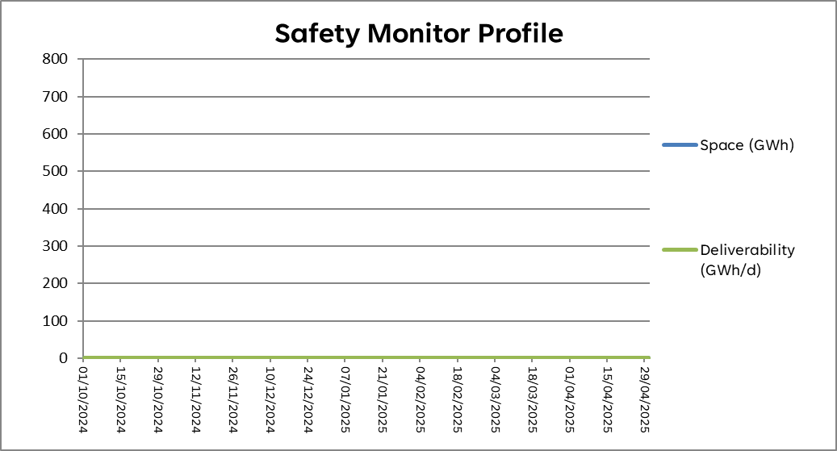

Notes on Demand Assumptions

National Gas Transmission forecasts both diversified demand and undiversified demand. The diversified peak day is the peak day for the whole country, whilst the undiversified peak day is the peak day for each area of the country added together. For planning and investing in the network, National Gas Transmission uses 1 in 20 peak day undiversified demand conditions (in addition to analysing other less severe weather conditions). This allows for the fact that there is no single profile of demand across the country associated with a 1 in 20 cold peak day, and therefore ensures sufficient transportation capacity is available to meet 1 in 20 demands under a range of conditions.

For security planning including Safety Monitors, National Gas Transmission uses diversified demand forecasts, which is the appropriate basis for assessing the balance between supply and demand on a national basis.

Contact:

Emergency & Incident Framework Team

Gas System Operations

National Gas Transmission

Warwick Technology Park

Gallows Hill

Warwick

CV34 6DA

E: [gasops.emergencyplanning@nationalgas.com](mailto:gasops.emergencyplanning@nationalgas.com)

**nationalgas.com**