|  |
| --- |
|  |

Gas Balancing Notification

Operational Guidance Material v2

January 2025

Operational Guidance Material

This document forms part of a suite of documents created to provide operationally focused guidance material; the aim of which is to support Shippers in increasing their understanding of non-routine commercial tools utilised by National Gas so that Shippers can be suitably prepared and ready to participant ahead of an event.

The Operational Guidance Documents detail the optimum way to perform the relevant process based on the current systems available. Where there are alternative ways in which the process could be completed the associated risks and benefits are explored. These documents are not intended to be used a detailed operating process / procedure; however, can be used by each Shipper organisation to assist in creating the operational process steps that are right for them.

These documents do not preclude changes or development to commercial tools in collaboration with industry in the future.

Gas Balancing Notification Information Overview

This document outlines the circumstances in which the Gas National Control Centre (GNCC) may issue a Gas Balancing Notification (GBN) and details the practicalities for users in receipt of such a warning. The following topics are covered:

* The objective of a Gas Balancing Notification
* Circumstances where a Gas Balancing Notification occurs
* Overview of the Gas Balancing Notification process
* Shipper/User action
* Additional information

Objective of a Gas Balancing Notification

The intent of a Gas Balancing Notification is to stimulate a rapid market response to address a projected NTS physical imbalance. Once a GBN has been issued, offers for gas trades from non-OCM subscribers, multiday trades and Demand Side Responses must be considered, in line with the UNC.

Circumstances where a Gas Balancing Notification occurs

A Gas Balancing Notification (GBN) is given ahead of, or during the Gas Day, based on expectations of a significant supply or demand event which suggests a substantial end of day NTS physical imbalance. This decision will be made by the GNCC based on an assessment of prevailing and projected NTS conditions (such as forecast demand, supply and linepack), plus other information deemed significant; there is no predefined formula to trigger a GBN.

Although there is no defined trigger for issuing a GBN, there are circumstances in which it will supersede a Margins Notice; although the GNCC is not limited to specific factors when determining whether issuance is appropriate.

A GBN remains in place until a separate Gas Balancing Notification Withdrawal notice is issued; a withdrawal notice indicates that the circumstances prompting the GBN have been resolved, or there is no longer an imminent risk to NTS physical balance or safety.

A GBN may be replaced by a Network Gas Supply Emergency (NGSE) if the relating issues can not be resolved, further details relating to NGSE can be found on the following webpage [Emergency response | National Gas](https://www.nationalgas.com/emergency-response)

Overview of the Gas Balancing Notification Process

A Gas Balancing Notification (GBN) is given ahead of, or during the Gas Day, based on expectations of a significant supply or demand event which suggests a substantial end of day NTS physical imbalance.

All current information about NTS balancing is available on the Gas Data Portal; [Gas system status | National Gas Transmission Data Portal](https://data.nationalgas.com/gas-system-status) By viewing this information Shippers can gain a view on the likelihood of a GBN being called by considering all the factors displayed, especially the supply and demand levels along with the utilised Linepack calculation, listed as a Supplementary Report on the Operational webpage, [Our Data | National Gas](https://www.nationalgas.com/our-businesses/operational-data/our-data) If a GBN is in place, or its potential precursor, a Margins Notice Warning, this will be displayed on the Gas Data Portal at the top next to “Gas System Status”.

Figure 1. GBN Issuance Process

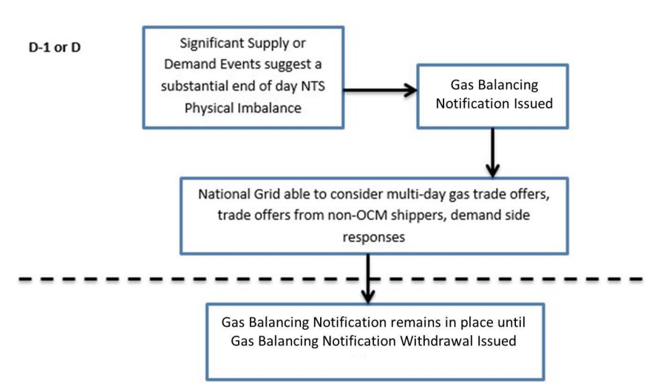

Following declaration of a GBN there are various actions Shippers may take based on their portfolio type/position at the time of issue (Figure 2). OCM offers will be accepted by National Gas via WebICE and translate through to Gemini, the user is then required to confirm the Opposite Flow Activity in Gemini.

Offer The Counter (OTC) offers will be accepted by National Gas via Gemini directly. The user counterparty will be contacted and requested to match the trade(s) on Gemini within 1 hour, and to complete a NBP15 Confirmation. Trades not matched within 1 hour will be rejected. P160 and NBP15 Confirmation proformas are available via the website: [Margins Notice & Gas Balancing Notification | National Gas](https://www.nationalgas.com/our-businesses/margins-notice-gas-balancing-notification)

Figure 2. GBN User Response Process

Shipper/User Action

For the ‘GBN commercial tool to function correctly it is expected that Shippers will facilitate as follows:

In advance of a GBN

• Maintain ANS contact details routinely to ensure important messages are received.

• Register for National Grid’s free text or email subscription service for Gas Balancing Notifications - [Margins Notice & Gas Balancing Notification | National Gas](https://www.nationalgas.com/our-businesses/margins-notice-gas-balancing-notification)

On receipt of a GBN

• Take immediate actions to rectify expected imbalances

• Place bids/offers on the OCM for in day trades

• Place bids/offers on the OCM for multiday trades (for a maximum of 7 gas days)

• Place bids/offers for DSR (see separate guidance)

• Non-OCM users to place bids/offers for OTC trades.

• OTC offers can be made via phone (0870 191 0636) users should be ready to confirm the details via the P160 proforma.

NOTE: National Gas will not accept OTC offers from OCM subscribers.

Additional Information

National Gas Balancing Notification Web Page

[Margins Notice & Gas Balancing Notification | National Gas](https://www.nationalgas.com/our-businesses/margins-notice-gas-balancing-notification)

National Gas Data Portal

[Home | National Gas Transmission Data Portal](https://data.nationalgas.com/)

Contact for more information

Energy Balancing Team - [box.energybalancing@nationalgas.com](mailto:box.energybalancing@nationalgas.com) / [Box.UniqueSites@nationalgas.com](mailto:Box.UniqueSites@nationalgas.com)

Customer Liaison Team - [box.operationalliaison@nationalgas.com](mailto:box.operationalliaison@nationalgas.com)