Trial Overview
Gas Demand Side Response Trial

Sarah Arnold – National Grid

Overview

This note provides an overview of the Gas Demand Side Response (DSR) trial that will take place in July 2015. The trial will aim to provide interested parties with the opportunity to gain a greater understanding of the DSR mechanism.

The DSR mechanism is a tool which is being designed by gas industry representatives to encourage daily metered (DM) consumers to offer to reduce their gas demand at times of system stress. The aim is that by providing DSR prior to entering a gas supply emergency, DM consumers have the potential to protect their critical loads by turning down other less critical loads and receive compensation for doing so. This has the potential to minimise the cost of demand interruptions and further reduce the likelihood of entering into an emergency.

As well as providing further understanding, the trial aims to gain greater insight on the appetite for this type of product which will help to inform the decision on whether to progress to implementation.

Trial Type

Following Ofgem’s decision to progress the Gas DSR Framework and Methodology to the trial phase, National Grid Gas (NGG) will be running a web based trial on the 13th-21st July 2015.

The web based trial was the option that received the most support from interested parties in a recent survey. It will allow participants to submit DSR offers electronically during a trial window period that lasts 7 working days. This should provide a greater degree of flexibility to make it as easy as possible for interested parties to be able to participate during this busy time of year.

The trial will aim, where possible, to simulate the processes outlined in the Framework and Methodology document. However, in some instances this may not always be possible e.g. the necessary system changes required to view DSR offers on the On the Day Commodity Market (OCM) will not be in place when the trial is run. Therefore, NGG may look to incorporate a Day Event closer to the product implementation date to help raise awareness of the finalised mechanism.
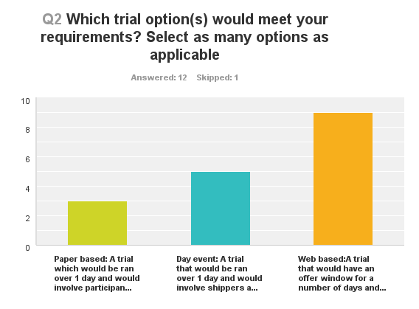
Results from DSR trial option survey

Participation Eligibility

DSR is targeted at large gas consumers with a Daily Metered Supply Point which has an annual quantity (AQ) greater than 2 million therms. In order to take part in the trial participants must meet this minimum AQ and be able to make a DSR offer of at least 100,000kWhs/day.

End Consumers interested in participating in the trial, and who meet these minimum criteria, can enter into discussions with their Shipper. They will need to decide what volume and price they would be able to offer and how they would want to offer it e.g. 7 day profiled offer. Shippers will then be able to register for the trial and submit DSR offers on behalf of their End Consumers. This aims to emulate the process outlined in the DSR methodology and Framework.

In instances where a Shipper is unable to take part, for the purpose of the trial only, there will be a facility for End Consumers to submit their own offers. The offers should be as realistic as possible, and imitate what the End Consumer would be able to offer in a real DSR scenario.

DSR Registration and Offers

Participants will be able to register their interest in taking part in the trial and will receive offer forms that they can fill in and submit. The registration form will be sent to all members of the DSR mailing list and will also be available of the Gas DSR webpage. Participants will need to fill in their information on the registration form and submit it between the 13th and 21st July 2015. Once submitted, the participant will receive an email that contains the DSR offer forms and their unique participant number.

The participant (Shipper or End Consumer as above) will need to fill in the offer form(s) that meets their requirements and will need to include the participant number, volume and price of their DSR offer. There is no limit on the number of forms that can be submitted, but each offer must meet the minimum amount of 100,000kWh.

The DSR offer can be made in the following ways:

- Daily Offer - A 7-day profiled offer lets the participant offer differing values of volume and price for each day of the week (the same values can be offered each day if preferred). This enables the participant to tailor the offer to their load profile. The offer will continuously roll over once the initial 7 day profiled offer has completed. These offers will be accepted on an individual day basis and will not be accepted as a 7 day lot.

- Fixed offer - A multi day offer allows the participant to offer DSR energy quantity for a set duration of time at a pre-determined price up to a maximum of 7 days e.g. a gas consumer can offer to turn down their DSR energy quantity for 4 days in a row at a set price. A multi day offer will be accepted as one offer for the number of days specified.

- A within day offer allows the participant to offer DSR energy quantity at a set volume and price for 1 day.

The offer can be made in multiple and separate tranches which can be priced individually according to the value of Lost Load (VoLL) associated with each tranche; but each tranche will need to meet the eligibility criteria e.g. minimum size of 100,000 kWs/day.

The Trial Process

The first phase of the trial involves the participant registering and then submitting the DSR offer form(s) that are most appropriate for them. They will need to input the volume and price of their offer(s) and submit the forms to NGG before the registration closing date. Once the 7 working day window for registration has finished, NGG will invite registered participants to participate in a second phase. NGG will then run a teleconference call for registered participants that will aim to provide further details and answer any questions or concerns regarding the second phase of the trial.

For the second phase, participants will be informed of the trial start date in which a Gas Deficit Warning (GDW) will be announced and NGG will provide market information including a system status update. After the GDW has been announced a mock OCM style feature will appear on the DSR webpage that will show the trial offers to date (volume and price). Participants will be able to amend existing offers, withdraw them or submit new offers. This window will allow participants time to discuss and submit new offers.

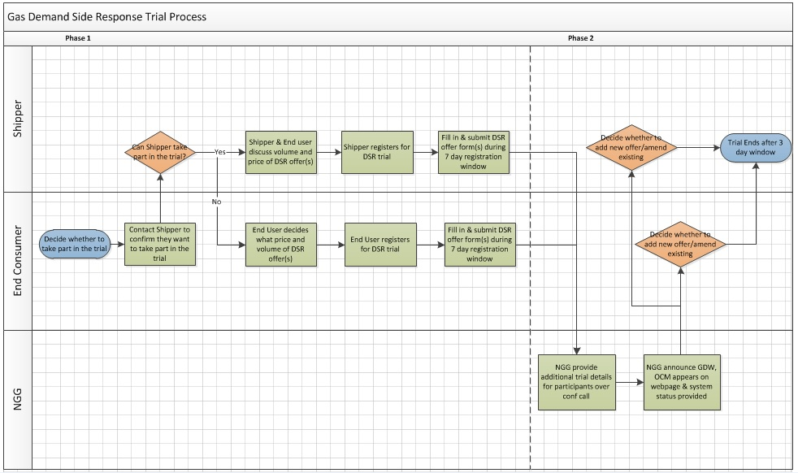

Trial Timeline

- 13th July 2015 – Trial Begins

- 13th-21st July 2015 - First Phase – Trial Registration and Submission of DSR offer forms over 7 working day window

- 23rd July 2015 – NGG run Teleconference for trial participants to better understand the second phase and to voice any questions or concerns

- 27th-29th July 2015 – Second Phase – NGG announce (mock) Gas Deficit Warning and re-open trial so that participants can submit new offers and withdraw or amend existing offers

- 29th July 2015 – Trial Ends

The first phase of the trial will commence on the 13th July when registration opens. Interested parties will be able to register and submit their DSR offers over a 7 day window that closes on the 21st July. Once registration has closed NGG will collate all of the offers and invite registered participants to take part in a teleconference which is likely to take place on the 23rd July. The teleconference will be an opportunity for NGG to further explain the trial process and for participants to voice any questions or concerns they may have.

On the 27th July the second phase of the trial will begin. NGG will send a mock GDW to participants and also provide them with a system status update. At this point all of the DSR offers submitted during the registration period will become visible on a mock OCM stack; this will only include volume and price, all other information provided will be treated as confidential. Participants will be able to use this new information to decide whether they want to amend their existing offers, submit new ones or make no changes at all. At the end of the 3 day window, on the 29th July the second phase of the trial will end and NGG will collate the results.

Summary

- To be eligible to take part in the trial, the participant must have an annual quantity of at least 2 million therms and be able to offer a volume of at least 100,000 kWhs/day.
- The trial will be web based and split into two phases
- The first phase will take place between the 13th-21st July 2015 and will involve interested parties registering for the trial and submitting their DSR offer(s)
- The second phase will involve NGG providing a GDW scenario and reopening the trial to allow participants to amend their offers, withdraw them, or submit new ones based on the market intelligence; this will take place between the 27th-29th July 2015
- In line with the DSR Framework and Methodology, Shippers can register and submit the DSR offer form(s) on behalf of their End Consumer. However, End Consumers will be allowed to submit their own offers if their Shipper is unable to participate in the trial; this is a feature of the trial only

